Task on CloudTrail & CloudWatch

1: Enable CloudTrail monitoring and store the events in S3 and CloudWatch log events.
Objective
Configure AWS CloudTrail to record AWS API activity and store the logs in:
- Amazon S3
- Amazon CloudWatch Logs
Steps
- Open AWS Console → CloudTrail
  - Go to Trails
  - Click Create trail
- Create the trail
  - Trail name: majeed-cloudtrail
  - Enable Multi-region trail
- Configure S3 storage
  - Select Create new S3 bucket
  - AWS created the bucket:
aws-cloudtrail-logs-929523583693-83ad7901
  - Enable Log file validation
- Configure CloudWatch Logs
  - Enable CloudWatch Logs
  - Log group:
aws-cloudtrail-logs-929523583693-b2e2c8b8
  - IAM role:
CloudTrail_CloudWatchLogs_Role
- Configure events
  - Select Management events
  - Enable Read and Write events
  - Keep API activity: All
- Create the trail
  - Click Create trail
  - Verify status shows Logging
Verification
S3 verification:
- Open the CloudTrail S3 bucket.
- Go to:
AWSLogs → Account ID → CloudTrail → us-east-1 → Year → Month → Date
- Verify .json.gz CloudTrail log files exist.
CloudWatch verification:
- Open CloudWatch → Logs → Log Management
- Open:
aws-cloudtrail-logs-929523583693-b2e2c8b8
- Open a Log stream
- Verify actual CloudTrail events are visible.
Final Result
CloudTrail → Records AWS API activity → Stores logs in S3 + CloudWatch Logs

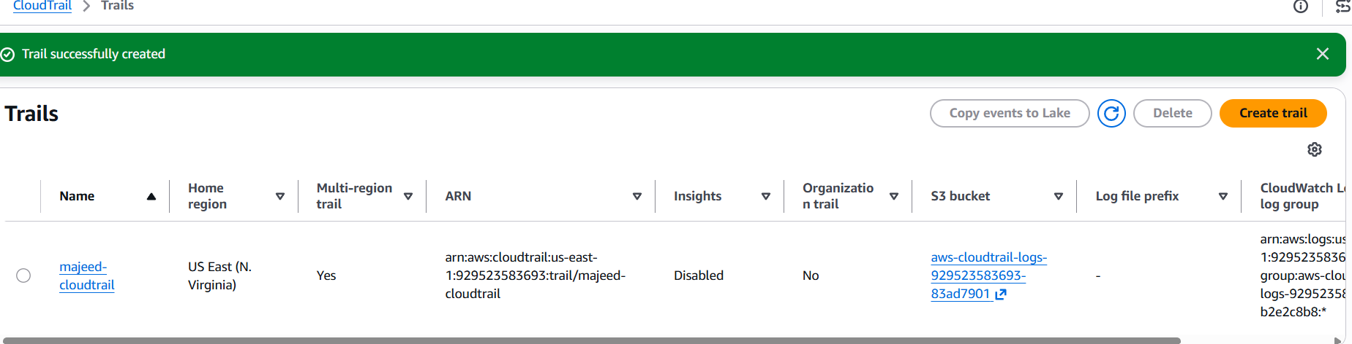
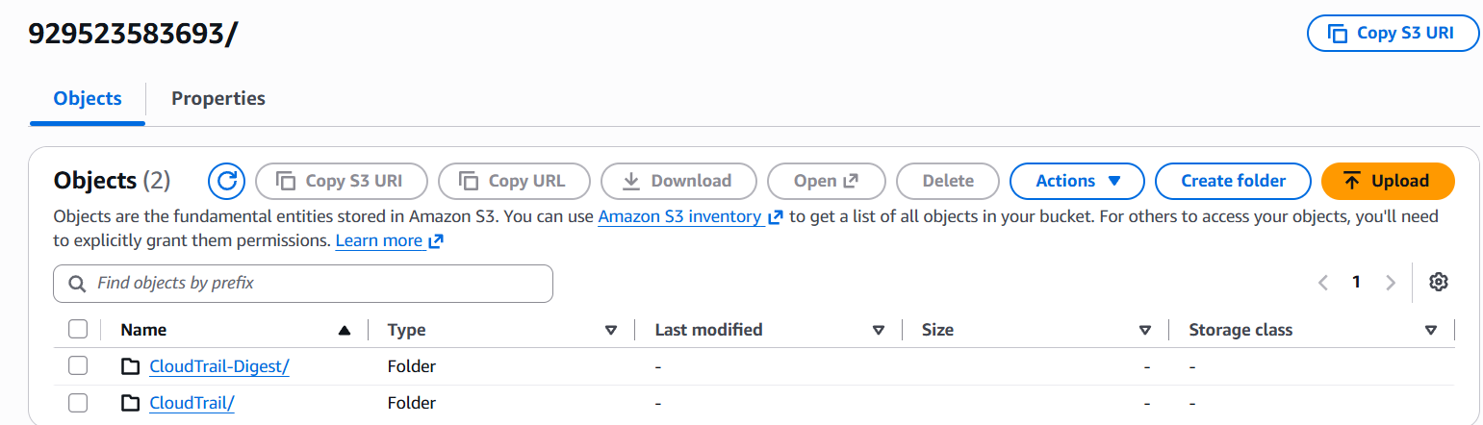
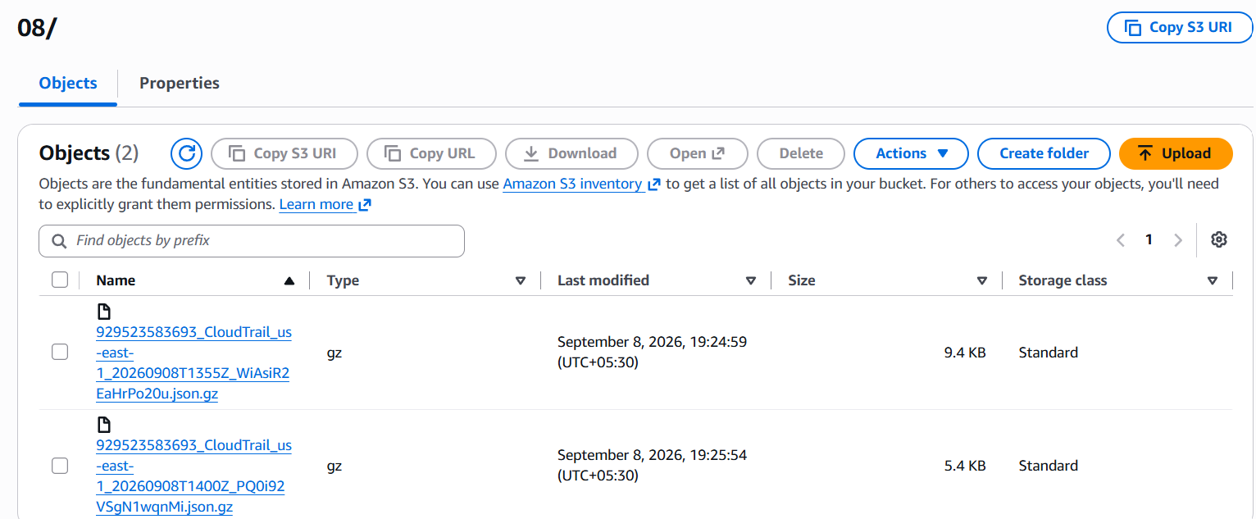

CloudWatch LogsLog ManagementLog groups.
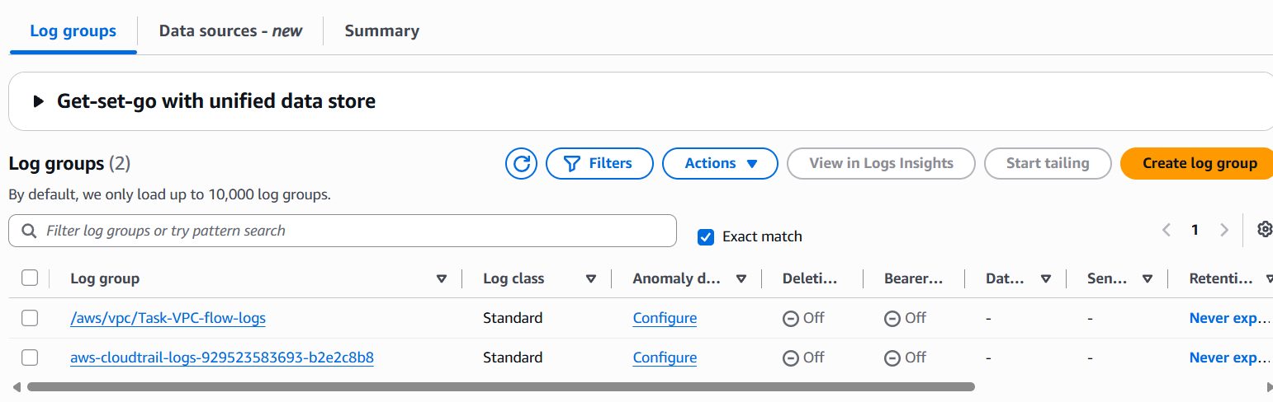
CloudWatch Log Streams created
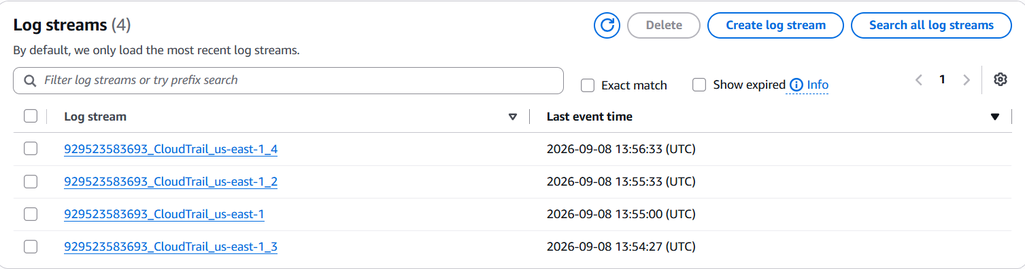
Click First 929523583693_CloudTrail_us-east-1_4
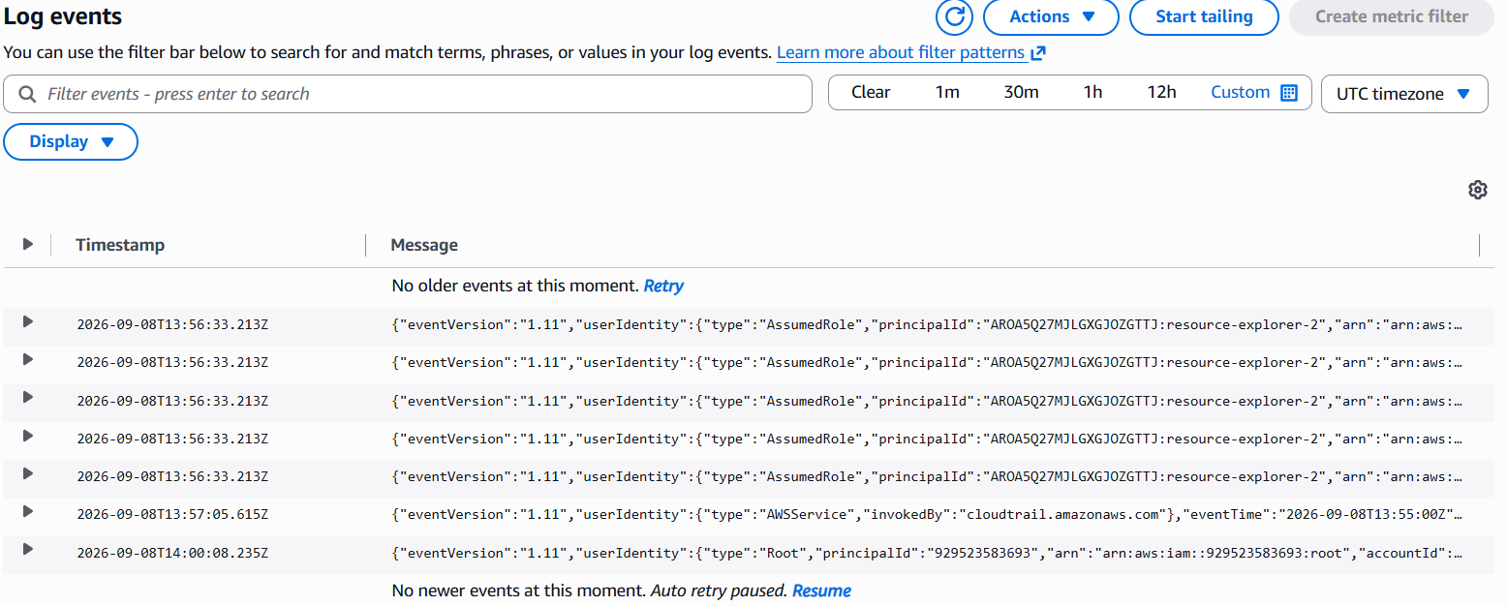
2: Enable SNS for CloudTrail to send alerts via email.
Objective
Configure Amazon SNS so CloudTrail can send notifications/alerts to an email address.
Steps Completed
- Open AWS Console → SNS
  - Search for Amazon SNS.
- Go to Topics
  - Click Topics from the left menu.
- Use the CloudTrail SNS Topic
  - AWS had already created an SNS topic:
aws-cloudtrail-logs-929523583693-efe8afd2
- Check Subscriptions
  - Open the topic.
  - Initially, Subscriptions was blank because no email was subscribed.
Next Step
Create an Email subscription to this SNS topic.
Protocol: Email
Endpoint: khanmajeedullah64@gmail.com
After creation, AWS sends a confirmation email. You must click Confirm subscription.
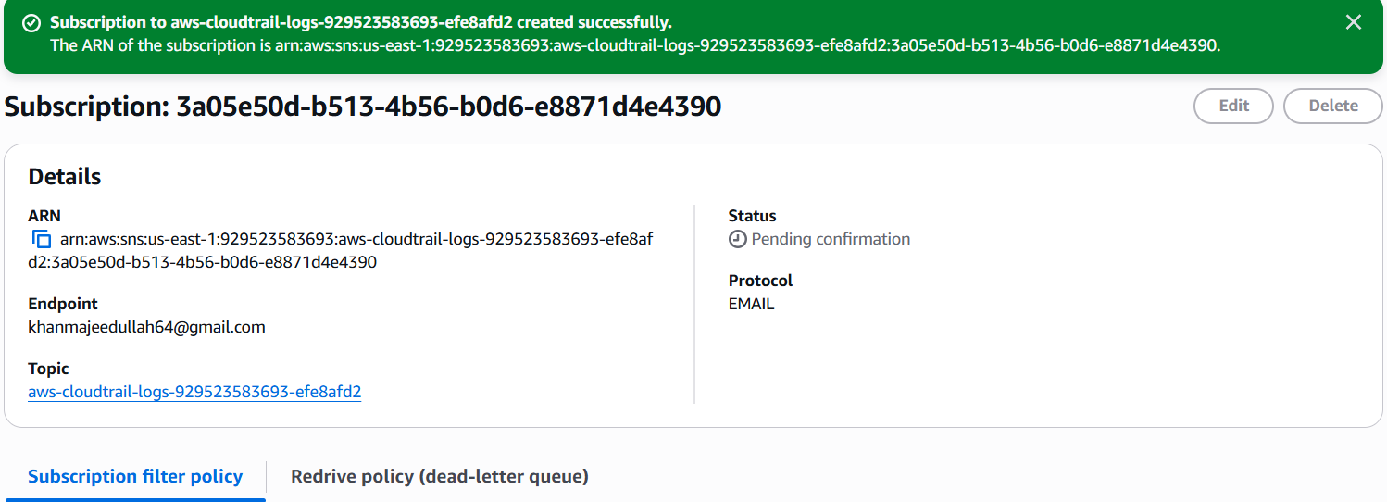
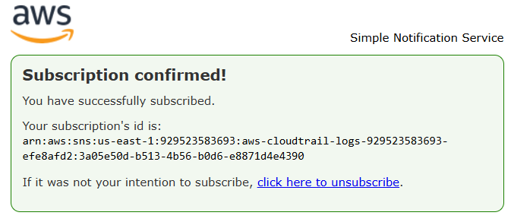
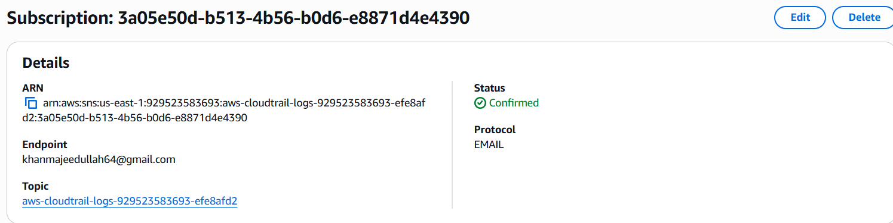
- Confirm Email Subscription
  - Open the confirmation email from AWS SNS.
  - Click Confirm subscription.
  - Verify the SNS subscription status changes to:
Confirmed.
- Test SNS Notification
  - Open the SNS topic.
  - Click Publish message.
  - Enter a test subject/message.
  - Click Publish message.
- Verify Email
  - Check your email inbox.
  - Confirm that the SNS notification is received.
Final Architecture
CloudTrail → S3 → SNS → Email ✅

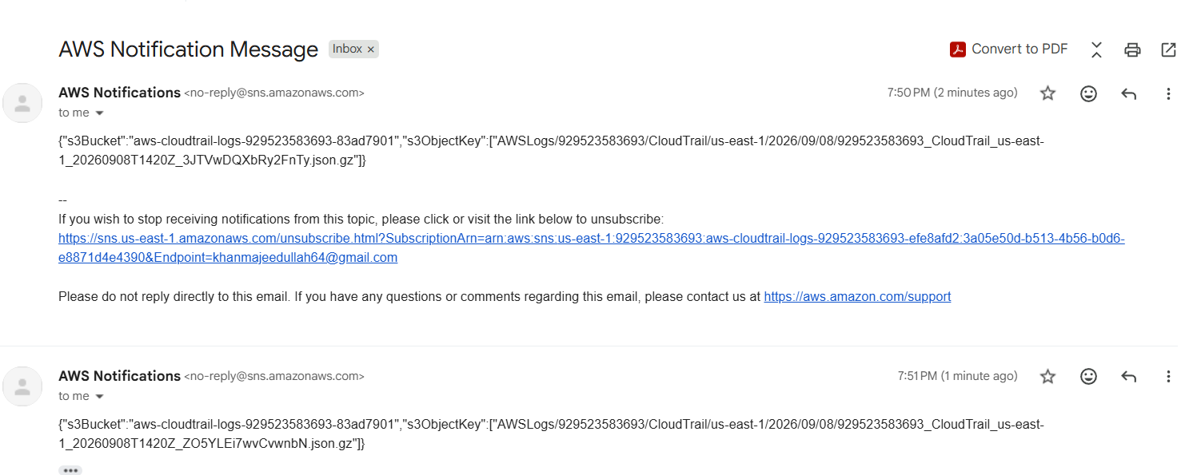

3: Configure CloudWatch monitoring and record the CPU utilization and other metrics of EC2.

Step 1: Launch EC2 Instance
- Open AWS Console → EC2 → Instances.
- Launch a new EC2 instance.
- Instance name: cloudwatch-monitoring
- Instance type: t3.micro
- AMI: Amazon Linux 2023
- Region: US East (N. Virginia) – us-east-1
- Launch the instance.
Step 2: Verify EC2 Instance
- Wait until the instance state is Running.
- Verify Status checks: 3/3 checks passed.
- Note the Instance ID:
i-0a8534f28b758ae1b
Step 3: Open CloudWatch
- Go to AWS Console → CloudWatch.
- Select Metrics.
- Select All metrics / Classic metrics.
- Choose EC2.
- Select Per-Instance Metrics.
Step 4: Find the EC2 Instance
- Search for:
cloudwatch-monitoring
- Select the instance:
i-0a8534f28b758ae1b
- CloudWatch displays the available EC2 metrics.
Step 5: Record CPU Utilization
- Select CPUUtilization.
- Choose Graph this metric only.
- Record the CPU utilization value.
Recorded value:
CPUUtilization = 0.2%
Step 6: Record Other Metrics
Record the following sample values:
Metric | Recorded Value
CPUUtilization | 0.2%
NetworkIn | 872 Bytes
NetworkOut | 1.028 KB
EBSReadBytes | 190.6 Bytes
EBSWriteBytes | 91.22 Bytes

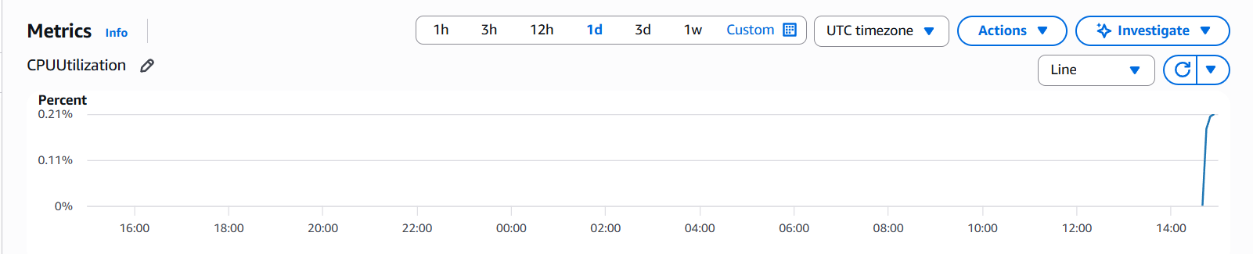
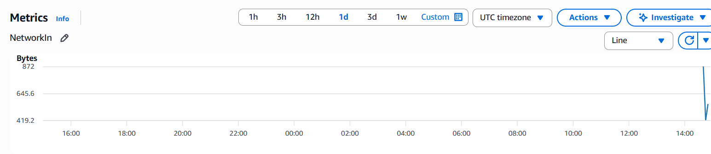
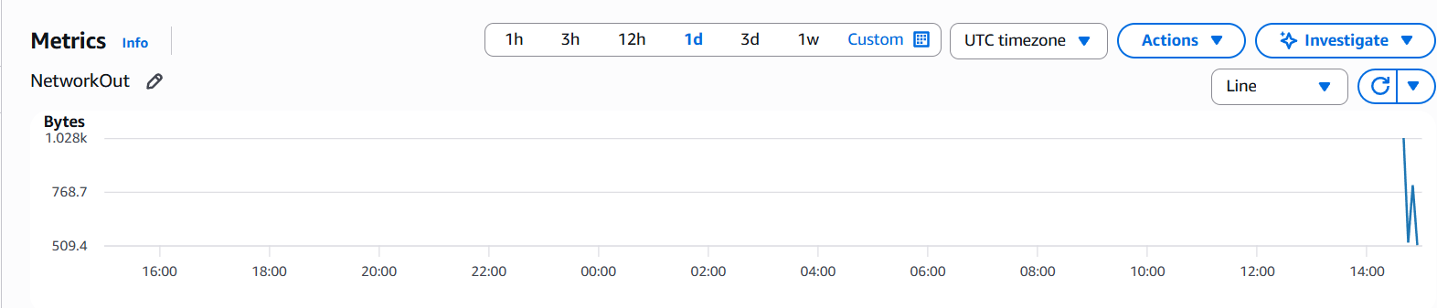
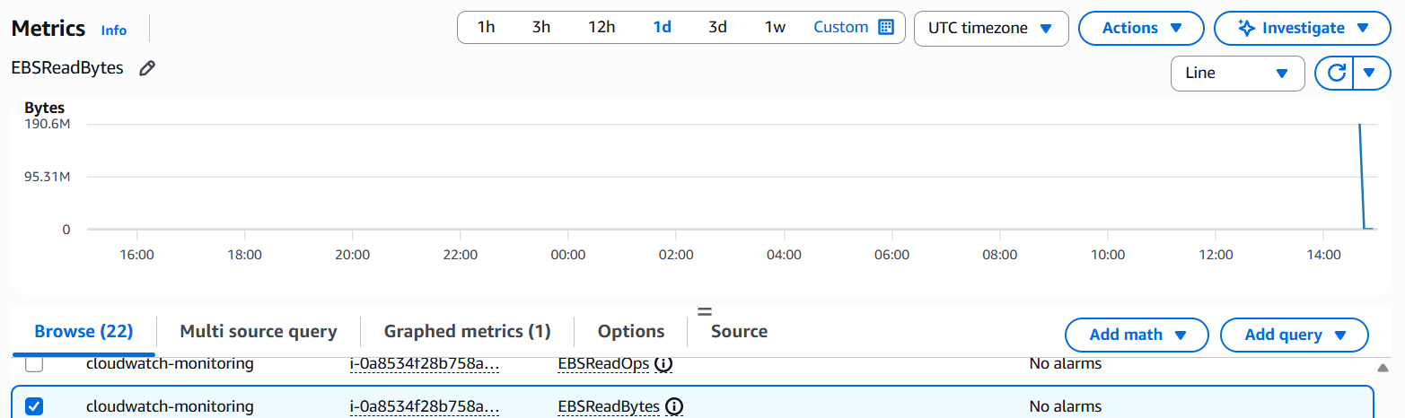
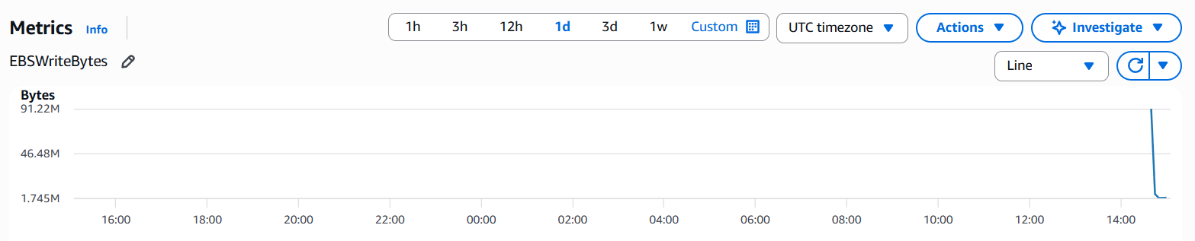

4: Create one alarm to send an alert to email if the CPU utilization is more than 70 percent.
Objective
Create an Amazon CloudWatch alarm that sends an email notification when the EC2 instance CPU utilization exceeds 70%.
Steps
1. Open CloudWatch
- Log in to the AWS Management Console.
- Open CloudWatch.
- Select the correct AWS Region: US East (N. Virginia) – us-east-1.
- Go to Alarms → All alarms.
- Click Create alarm.
2. Select the EC2 CPU Metric
- Click Select metric.
- Select EC2.
- Select Per-Instance Metrics.
- Find and select the required EC2 instance.
- Select CPUUtilization.
- Click Select metric.
3. Configure the Alarm Condition
Configure the following:
- Statistic: Average
- Period: 5 minutes
- Threshold type: Static
- Condition: Greater than (>)
- Threshold value: 70
The condition becomes:
CPUUtilization > 70% for 1 datapoint within 5 minutes
4. Configure Email Notification
Under Configure actions:
- Select In alarm as the alarm state trigger.
- Select Select an existing SNS topic.
- Select the SNS topic:
EC2-CPU-Alert
SNS Topic ARN:
arn:aws:sns:us-east-1:929523583693:EC2-CPU-Alert
- Make sure the email subscription for this SNS topic is confirmed.
5. Name the Alarm
Set the alarm name to:
EC2-CPU-Above-70
Click Next and complete the alarm creation.
6. Verify the Alarm
Go to:
CloudWatch → Alarms → All alarms
Verify that the alarm appears as:
EC2-CPU-Above-70
The condition should show:
CPUUtilization > 70 for 1 datapoints within 5 minutes
The alarm actions should be:
Actions enabled
Initially, the alarm may show Insufficient data while CloudWatch is collecting metric data. After sufficient data is collected, it should normally change to OK if CPU utilization remains below 70%.
Final Result
The CloudWatch alarm EC2-CPU-Above-70 was successfully created.
When the EC2 instance CPU utilization exceeds 70%, CloudWatch will change the alarm to In alarm and send an email notification through the EC2-CPU-Alert SNS topic.
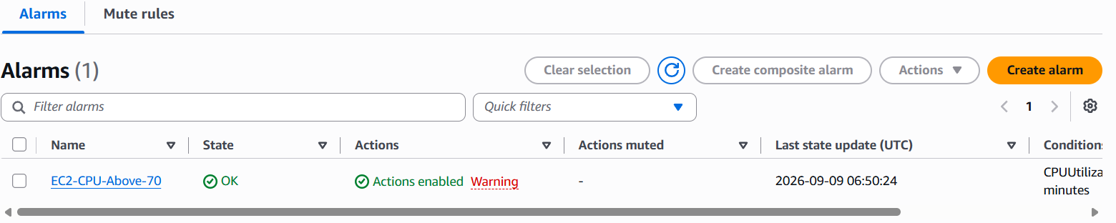
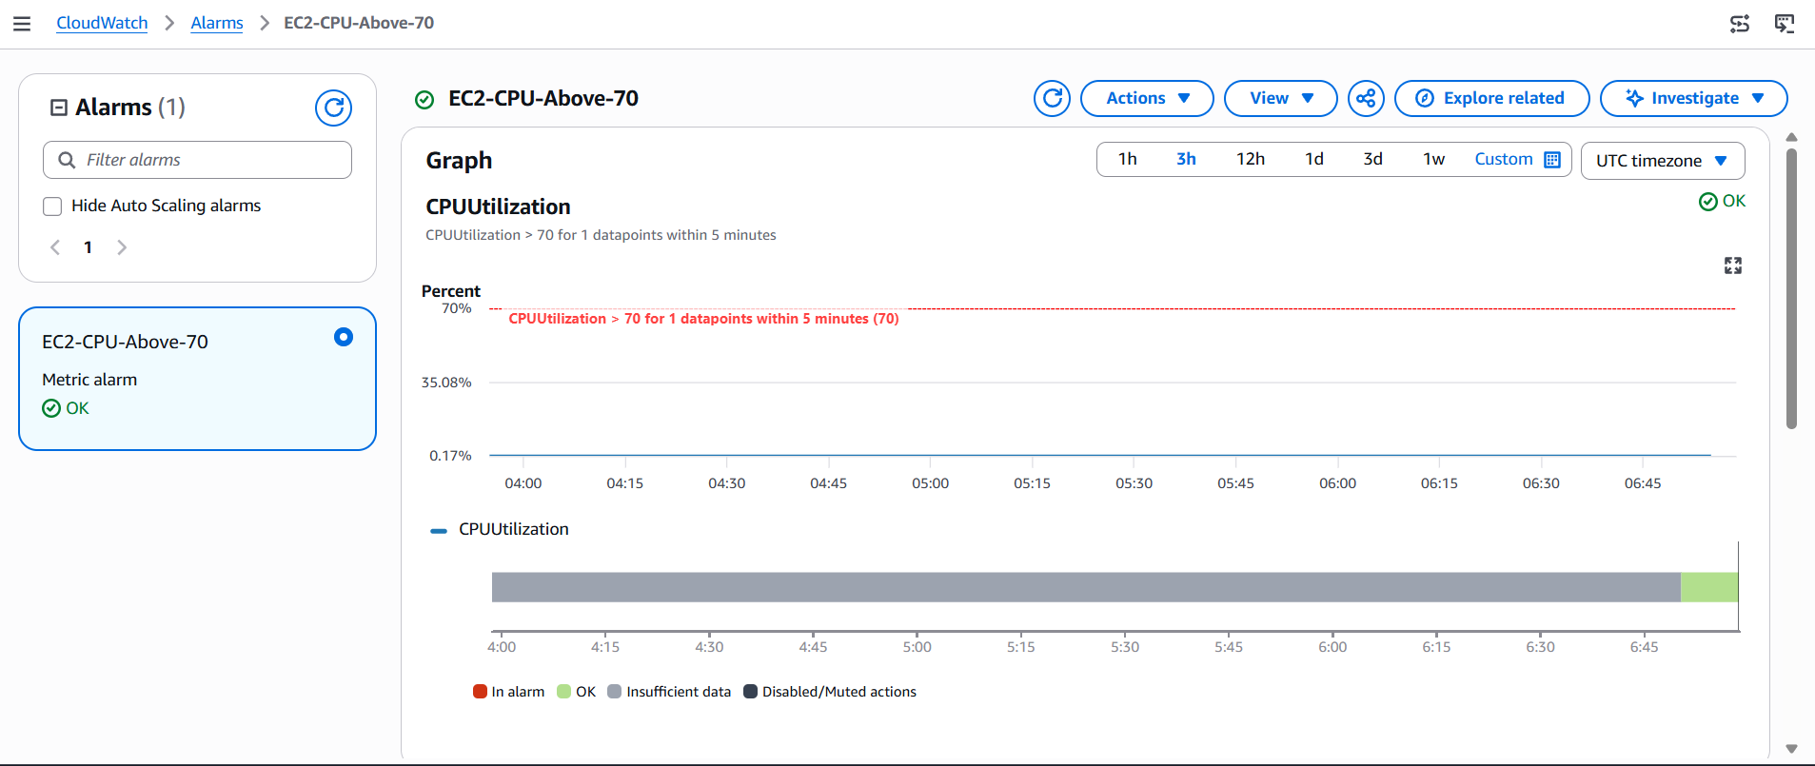
5: Create a Dashboard and monitor the Tomcat service whether it is running or not and send the alert.
Install CloudWatch Agent
Configure it to monitor the Tomcat process
Send the Tomcat status metric to CloudWatch
Create a CloudWatch Dashboard
Create an alarm
Connect the alarm to SNS email
Test by stopping Tomcat

Objective
Create a CloudWatch Dashboard to monitor the Tomcat service and configure an email alert when Tomcat stops running.

Step 1: Install CloudWatch Agent
On the EC2 instance, install the CloudWatch Agent.
sudo dnf install amazon-cloudwatch-agent -y
Check installation:
rpm -qa | grep amazon-cloudwatch-agent

Step 2: Create CloudWatch Agent Configuration
Create/edit the configuration:
sudo vi /opt/aws/amazon-cloudwatch-agent/etc/amazon-cloudwatch-agent.json
Use:
{
"metrics": {
"namespace": "Custom/Tomcat",
"metrics_collected": {
"procstat": [
{
"pattern": "org.apache.catalina.startup.Bootstrap",
"measurement": [
"pid_count"
],
"metrics_collection_interval": 60
}
]
}
}
}
What this does
- Custom/Tomcat → creates a custom CloudWatch namespace.
- procstat → monitors a process.
- Bootstrap → identifies the Tomcat Java process.
- pid_count → shows whether the Tomcat process exists.
- 60 → sends the metric every 1 minute.
Expected value:
- 1 = Tomcat is running
- 0 = Tomcat is stopped

Step 3: Start CloudWatch Agent
sudo /opt/aws/amazon-cloudwatch-agent/bin/amazon-cloudwatch-agent-ctl \
-a fetch-config \
-m ec2 \
-c file:/opt/aws/amazon-cloudwatch-agent/etc/amazon-cloudwatch-agent.json \
-s
Check:
sudo systemctl status amazon-cloudwatch-agent
Expected:
Active: active (running)

Step 4: Attach IAM Role to EC2
The EC2 instance needs permission to send metrics to CloudWatch.
Attach an IAM role containing:
CloudWatchAgentServerPolicy
In this task, the existing instanceRole was used.
After attaching the role, restart the agent:
sudo systemctl restart amazon-cloudwatch-agent

Step 5: Check CloudWatch Metric
Go to:
AWS Console → CloudWatch → Metrics → All metrics → Custom namespaces → Custom/Tomcat
Find:
procstat_lookup_pid_count
The Tomcat process should show approximately:
1
when Tomcat is running.

Step 6: Create CloudWatch Dashboard
Go to:
CloudWatch → Dashboards → Create dashboard
Dashboard name:
Tomcat-Monitoring-Dashboard
Add the metric:
Custom/Tomcat
→ procstat_lookup_pid_count
Save the dashboard.

Step 7: Create Tomcat Down Alarm
From the Tomcat metric, select:
Create alarm
Use:
Statistic: Average
Period: 1 minute
Threshold type: Static
Condition: Lower
Threshold: 1
Datapoints: 1 out of 1
Condition:
procstat_lookup_pid_count < 1
Alarm name:
Tomcat-Service-Down
Meaning
Tomcat running → metric = 1 → Alarm OK
Tomcat stopped → metric = 0 → Alarm ALARM

Step 8: Configure SNS Email
For the alarm action:
Alarm state → In alarm
Select SNS topic:
EC2-CPU-Alert
Email:
khanmajeedullah64@gmail.com
If status says:
Pending confirmation
open the AWS SNS confirmation email and click:
Confirm subscription
After confirmation, SNS should show:
Confirmed

Step 9: Test the Alarm
Stop Tomcat:
sudo systemctl stop tomcat
Wait approximately 1–2 minutes.
CloudWatch should detect:
procstat_lookup_pid_count = 0
Alarm should become:
Tomcat-Service-Down → ALARM
An SNS email alert should be received.

Step 10: Start Tomcat Again
sudo systemctl start tomcat
Check:
sudo systemctl status tomcat
Expected:
Active: active (running)
After CloudWatch receives the new metric, the alarm should return to:
Tomcat-Service-Down → OK

Final Verification
Check:
CloudWatch → Alarms
Expected:
Tomcat-Service-Down → OK
EC2-CPU-Above-70 → OK
Check:
CloudWatch → Dashboards
Expected:
Tomcat-Monitoring-Dashboard
Check:
SNS → EC2-CPU-Alert → Subscriptions
Expected:
khanmajeedullah64@gmail.com → Confirmed
Task 5 Status
✅ CloudWatch Agent configured
✅ Tomcat process metric created
✅ Dashboard created
✅ Tomcat-down alarm created
✅ SNS email configured
✅ Email subscription confirmed
✅ Alarm tested
✅ Tomcat restarted
✅ Alarm returned to OK

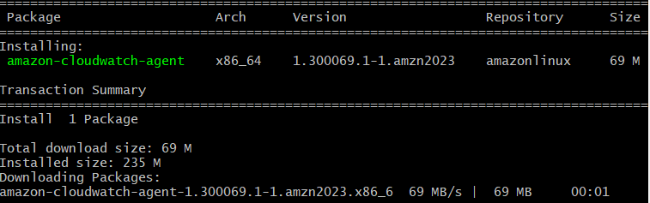
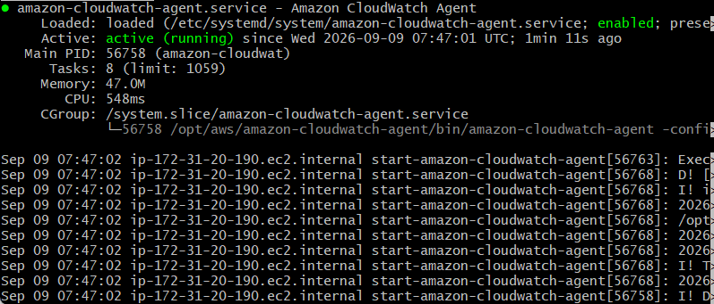
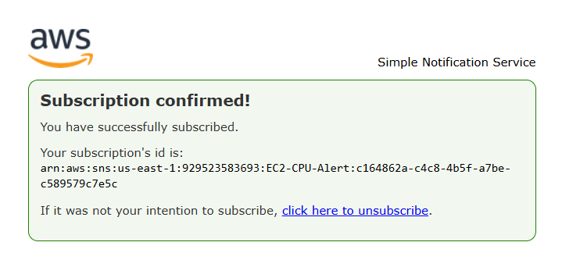
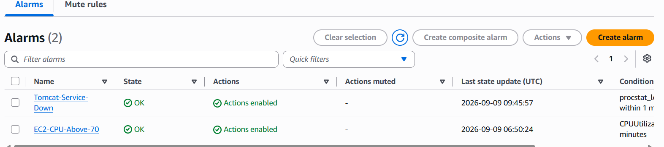
Sudo systemctl stop tomcat
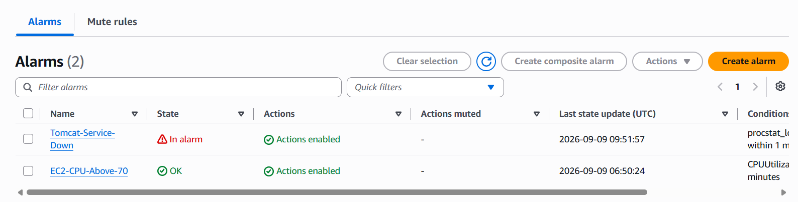
Simple Notification Service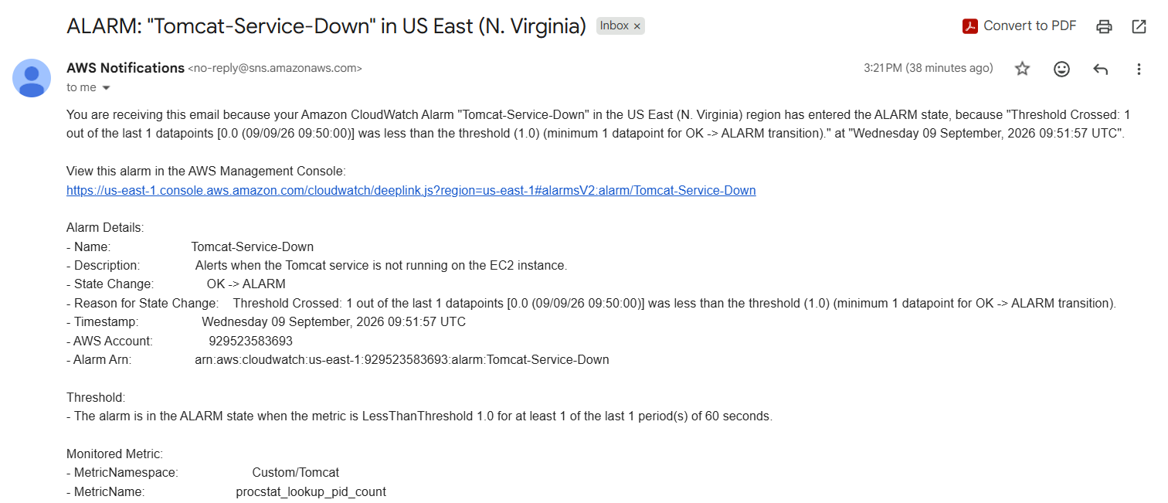
6: Create a Dashboard and monitor the Nginx service to send the alert if Nginx is not running.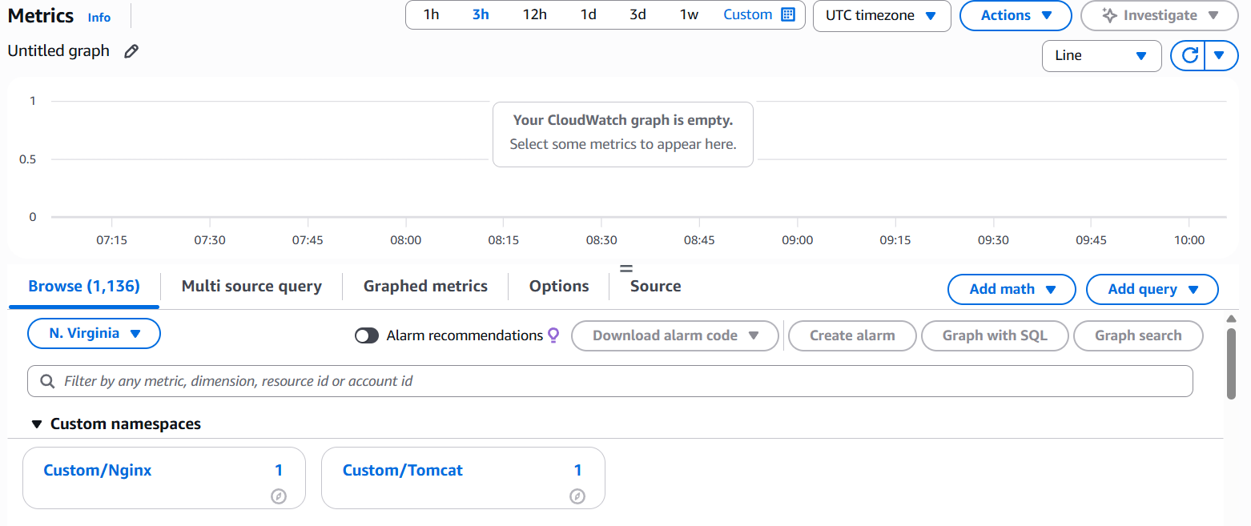
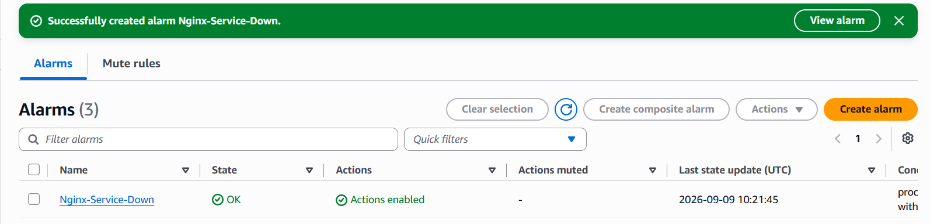
Sudo systemctl stop nginx
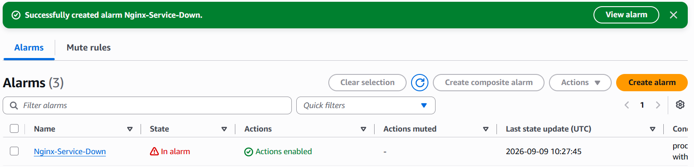

Simple Notification Service

